./pp

Studio 5

Name and Student Id: Xin Xu 30421225

Self-Evaluation:

|  |  |  |  |  |  |
| --- | --- | --- | --- | --- | --- |
| Need Help | Work in Progress | Pass | Credit | Distinction | ***High Distinction*** |

Tutor Evaluation:

|  |  |  |  |  |  |
| --- | --- | --- | --- | --- | --- |
| Incomplete | Needs improvement | Pass | Credit | Distinction | High Distinction |

Task 5.1:

{Answers}

Defer:

Defer scripts guarantees the order of execution in which they appear in the page. Because it downloads the file during HTML parsing and only execute when the all parser has been completed.

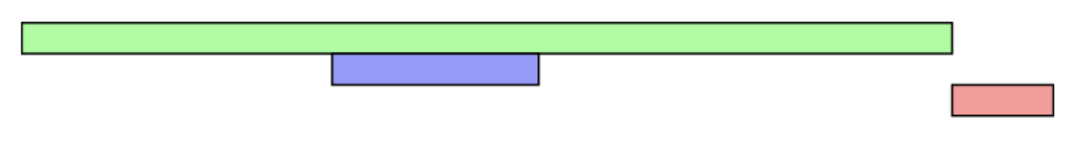

Async:

Async scripts are executed as soon as the script is loaded, so it doesn't guarantee the order of execution.

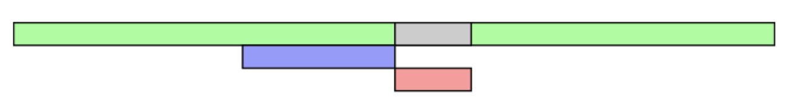

{Screenshots}

A screenshot of a website using Notify.js and code

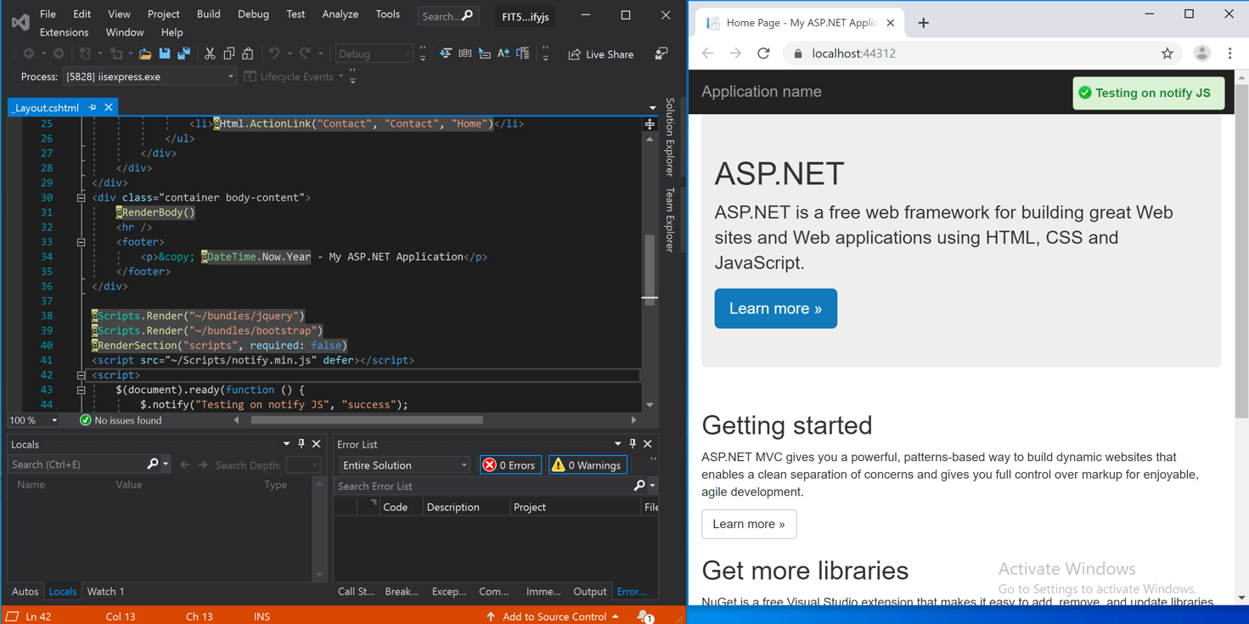

{Link to code repository}

{References}

https://stackoverflow.com/questions/10808109/script-tag-async-defer

{URLs}

https://drive.google.com/drive/u/1/folders/1EJm0eM0xhxAZXouHovffv0YsfZgxz1be

Task 5.2:

{Answers}

I have done this task

{Screenshots}

A screenshot of jquery datepicker

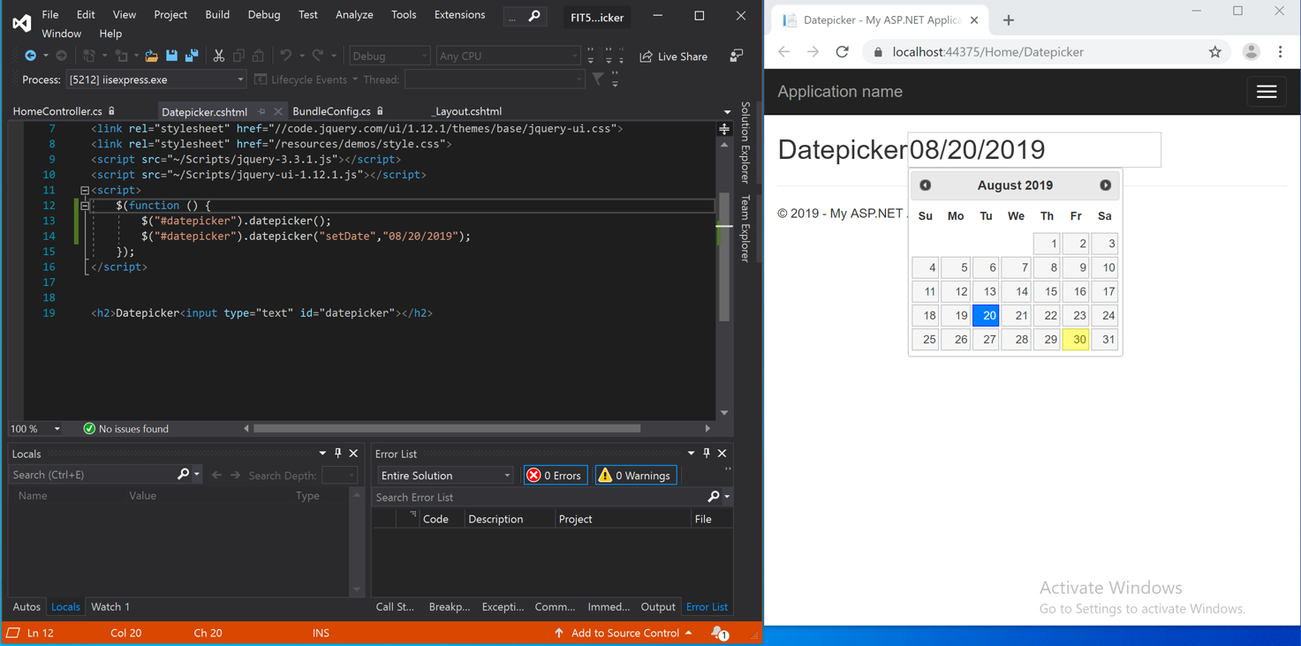

A screenshot of bootstrap datepicker

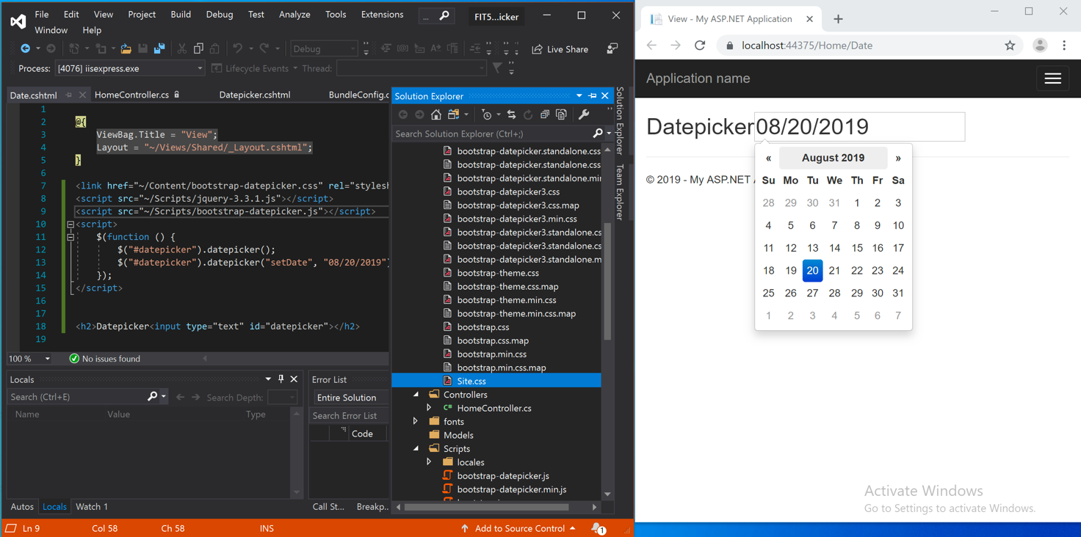

{Link to code repository}

{References}

{URLs}